Task 1: Install MySQL Community Server
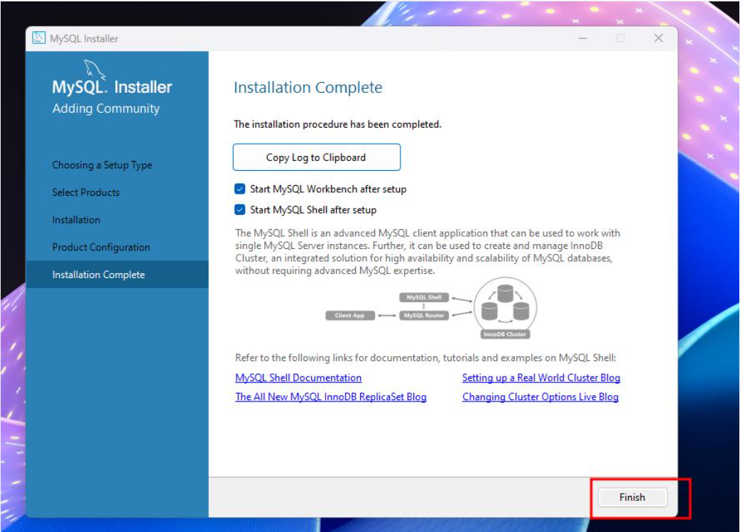
Task 2: Create music_streaming_db
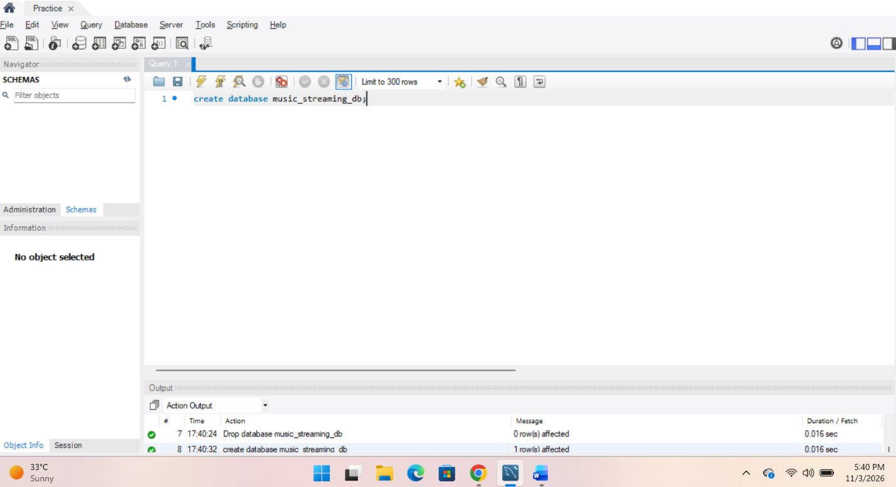

Task 3: Create food_delivery_db
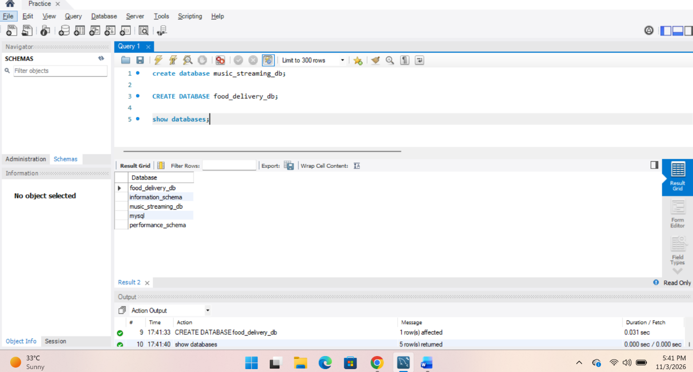
Task 4: Differences between MySQL and PostgreSQL
Features | MySQL | PostgreSQL
1. Performance | Known for fast read operations and web applications. | Strong in complex queries and advanced data processing.
2. Features | Supports basic relational database features, JSON, and multiple storage engines. | Supports advanced SQL, JSONB, custom data types, and extensibility.
3. Use cases | Commonly used for websites and web applications. | Commonly used for complex applications, analytics, and enterprise systems.

